# Overview

This document contains the necessary information to build the Switch-Operated Rotating Phone Stand, a rotating stand controlled by switches.

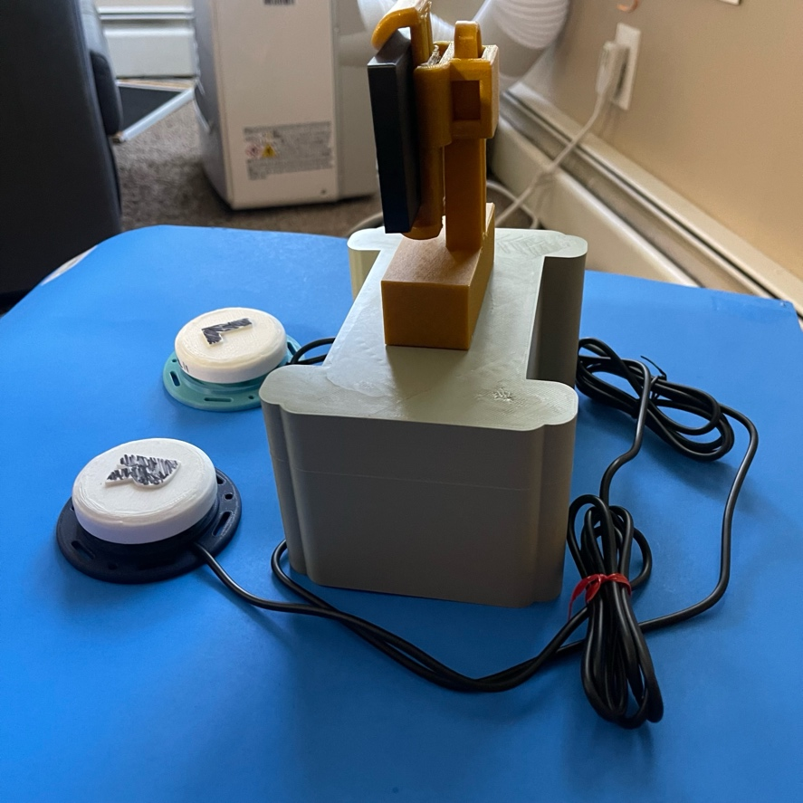

# Maker Checklist

This list provides an overview of the steps required to build and deliver the Rotating Phone Stand .

## Maker To Do List

* **Read through this guide**  
  Make sure you understand the parts, tools, and steps needed to build the device.
* **Gather the parts**  
  Collect all the 3D printed components and electronic parts needed for the build.
* **Assemble the phone stand**  
  Build the device step by step. Break it into smaller sections if helpful.
* **Upload the code**  
  Use the Arduino software to load the code onto the board.
* **Test the device**  
  Check that the rotation and switches work as expected.
* **Provide the User Guide**  
  Give the user a printed copy or send the PDF, depending on what they asked for.

## Items to Give to User

Provide the following items to the user:

* The assembled Switch-Operated Rotating Phone Stand
* Two wired switches
* USB cable or battery pack
* User Guide

# 

# Supplies List

### Supplies

|  |  |  |  |  |
| --- | --- | --- | --- | --- |
| **Item ID** | **Description** | **Quantity** | **Required/Recommended** | **Notes** |
| T01 | Wire Stripper | 1 | Required | Strip wire insulation |
| T02 | Wire Cutter | 1 | Required | Cut wires |
| T03 | Soldering Iron | 1 | Recommended | For strong wire connections |
| S01 | Solder | As Needed | Recommended | Use with soldering iron |
| T04 | Multimeter | 1 | Optional | Test connections |
| S02 | Wires | As Needed | Required | For wiring |
| S04 | Arduino board | 1 | Required | Arduino Uno |
| S05 | Servo motor | 1 | Required | 180 or 360 |
| S06 | Switches | 2 | Required | Interact/Touch |
| S07 | Resistors | As Needed | Conditional | For switches |
| S08 | Breadboard | 1 | Optional | For easy wiring |
| S09 | Power Source | 1 | Required | (USB or battery) |

# Assembly Guide

Building the Switch-Operated Rotating Phone Stand involves assembling the 3D printed components and connecting the electronic components. These stages are covered in the following steps.

### **1. Assembling the 3D Printed Parts**

* Start by printing all the required parts.
* Check that each part looks clean and fits together properly.
* Build the main base of the phone stand using these parts.

### **2. Installing and Connecting the Servo Motor**

#### **2.1 Attach the Servo Motor**

* Place the servo motor into its spot on the printed base.

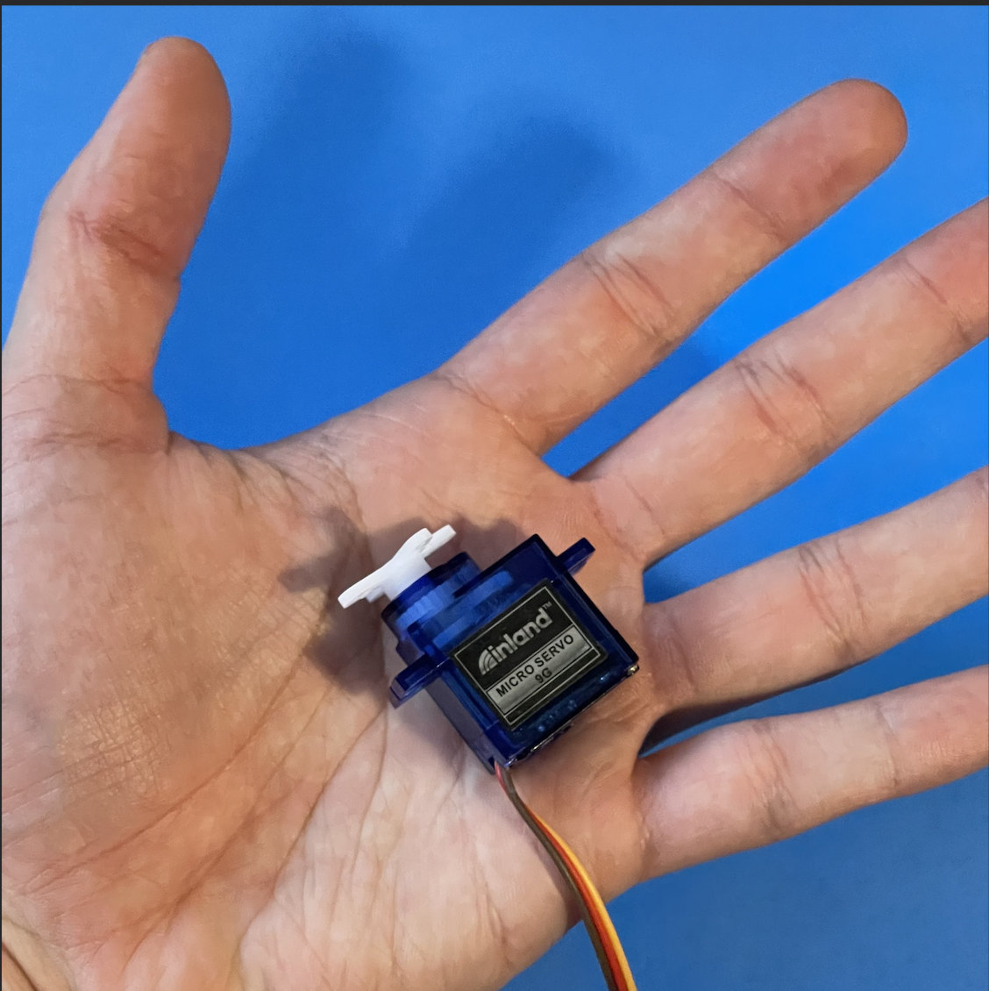 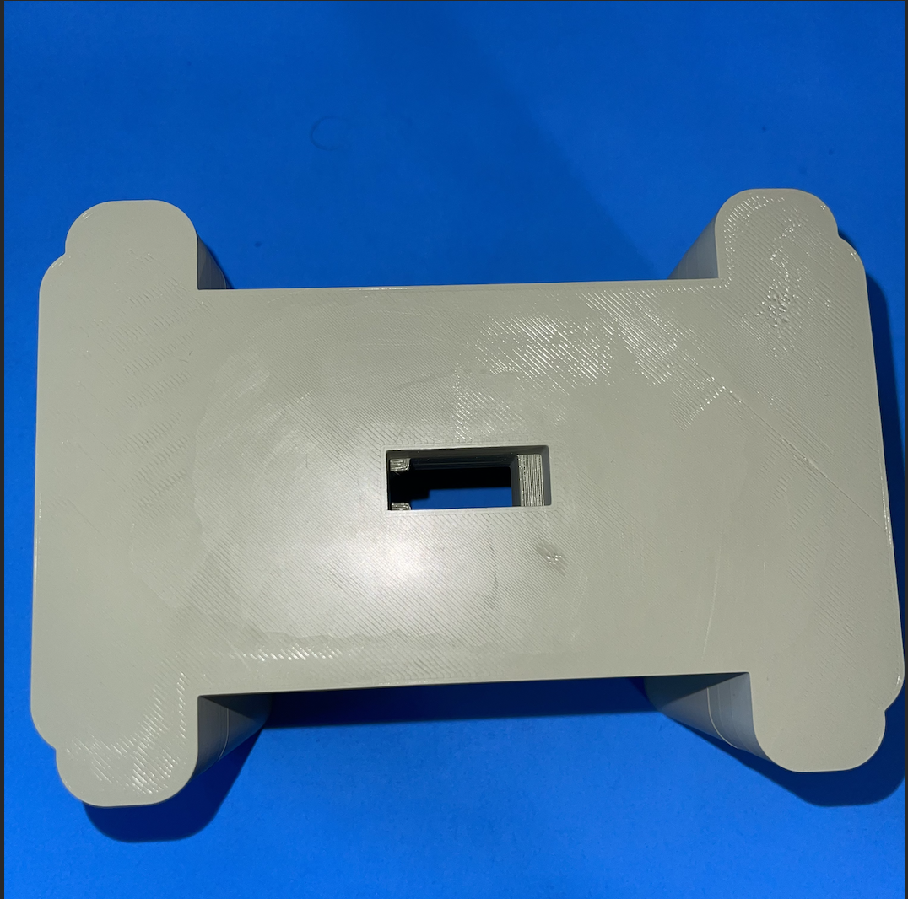 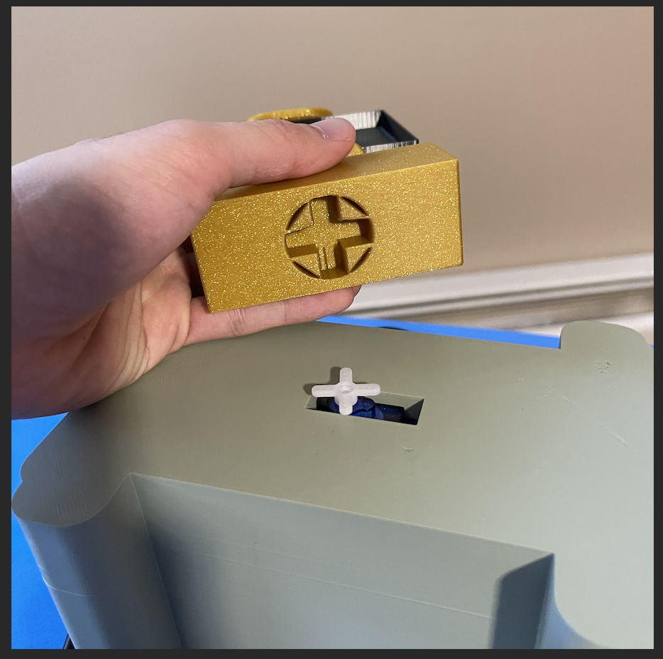

#### **2.2 Connect the Servo Motor to the Arduino**

The servo motor has three wires. For a more secure connection, the servo motor wires can be soldered to wires leading to the Arduino. Connect them like this:

Red Wire 1 (Power): Connect to 5V on the Arduino

Red Wire 2 (Ground): Connect to GND on the Arduino

White Wire (Signal): Connect to a digital pin on the Arduino (D9)

Make sure the pin you choose matches what’s written in your Arduino code.

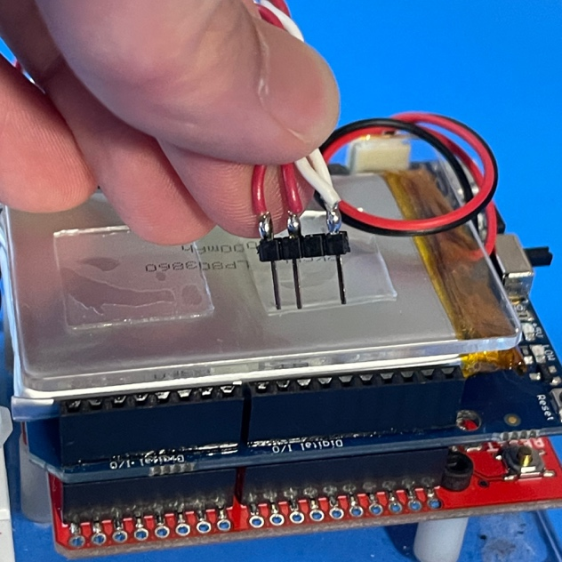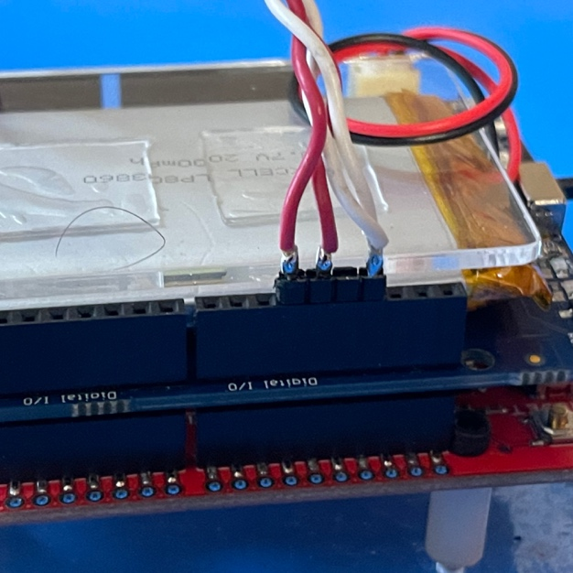

### **3. Connecting the Switches**

#### **3.1 Wiring the Switches**

Each switch has two pins (metal legs). Set them up like this:

* **Switch 1:**
  + One pin to an Arduino digital pin (like **D2**)
  + One pin to **GND**
* **Switch 2:**
  + One pin to another digital pin (like **D3**)
  + One pin to **GND**

**

A printed pair of switches compatible with the RPS

#### **3.2 Add a Resistor (If Needed)**

* To help the Arduino read the switch correctly, you may need a **10kΩ resistor**.
* This resistor should go between the Arduino pin and **5V** (for pull-up) or **GND** (for pull-down), depending on how your switch is set up.

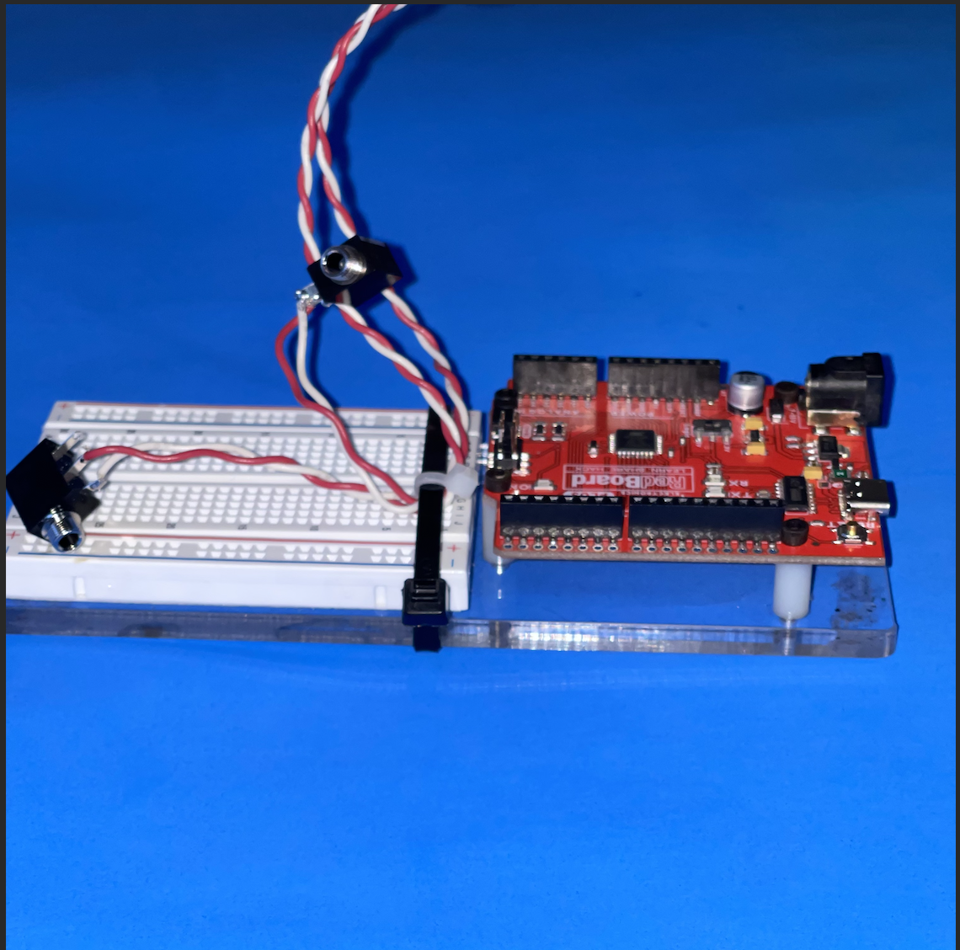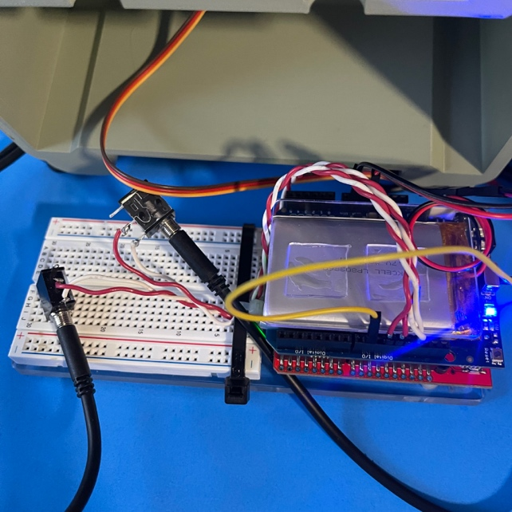

### **4. Uploading the Code to the Arduino**

#### **4.1 Install the Arduino Program**

* Download and install the Arduino IDE from: <https://www.arduino.cc/en/software>

#### **4.2 Open the Code**

* Open the file named Servo180MotorAngleProgram.ino in the Arduino IDE.

#### **4.3 Choose the Right Settings**

* In the **Tools** menu, choose your Arduino board (Arduino Uno).
* Select the correct port under **Tools > Port**.

#### **4.4 Upload the Code**

* Click the **Upload** button to send the code to your Arduino.

### **5. Final Steps**

#### **5.1 Power the Arduino**

* Plug the Arduino into a power source using a USB cable or a battery.

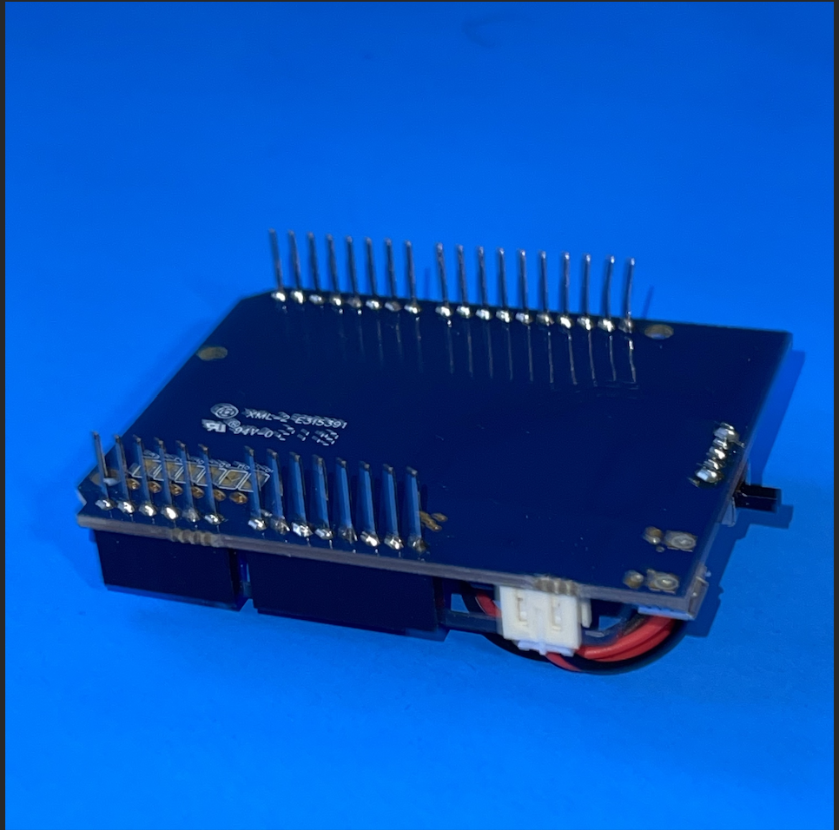

A batter pack compatible to power the arduino & servo motors

#### **5.2 Attach the Electronics to the Base**

* Secure the Arduino and other parts onto the 3D printed base.
* Make sure all wires are out of the way and nothing blocks the rotating parts.

**Testing**

To check if the device works, first, look for lights on the Arduino chip to make sure it's getting power. Then, press each of the switches to see if they make the phone holder turn.>

**Troubleshooting**

If the device isn't working, try uploading the code again to the Arduino chip using the Arduino program. Then, test it again. If it still doesn't work, try using different switches to see if the old ones are not responding.